
INDIAN SCHOOL AL WADI AL KABIR

Worksheet 2026-2027

Class: XI | Department: Computer Science | Date of submission: 26.04.26
Worksheet -3 | Topic: Boolean Algebra | Note: To be written in NB

1. Prove the Boolean Laws shown below using Truth Table.

1. X+ X’Y = X + Y
2. X + XY = X
3. X+ Y Z = ( X + Y ) ( X + Z)

2. State and prove De Morgan's Theorems using truth table

3. Convert the following logic gate circuit into a Boolean expression. (Write the Boolean expression for the given circuits)

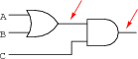
1.

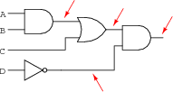
2

3.

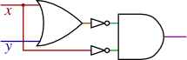

4.
- Draw Logic circuit for y = A.C + B.C’ + A’.B.C
- Draw Boolean Logical Circuit from the given Boolean
expression: Q = A.B + B.C.(B+C)
- Draw Logic circuit for y = A.C + B.C’ + A’.B.C
- Draw a circuit diagram corresponding to the following Boolean Expression:
a) y = A+C .B+C’ . A’+B+C
b) F = A’.B.C.(A+D)’
c) F = A.B’+C’.D
d) F = (U.V’)+(U’.W’)
e) F = A.B + A.C’ + B’.A’.C
f) F = (X+Y).(X’+Z’).(Y+Z)

5. Obtain logic expression for the following logic circuit:

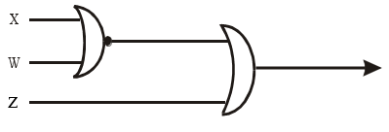

6. Find the result of the following logic circuit

